E-Commerce Retail Analytics: Data Cleaning & Exploratory Analysis
Course Work: Week 1 Technical Documentation
Estimated Time Frame: 30–35 Hours
Domain: E-Commerce / Retail Operations

1. Executive Summary
This document delivers a comprehensive exploratory data analysis (EDA) and data cleansing pipeline for transactional retail datasets. By uniting customer profile metrics with daily shopping basket logs, this project provides a clean foundational dataset for future predictive modeling and customer segmentation.
Key outcomes include:
- Identified and resolved missing data, anomalous customer ages, and duplicated records.
- Established baseline metrics across order volume, customer tenure, and demographic distributions.
- Delivered actionable insights regarding peak purchasing periods and target demographic profiles.

1. Data Ingestion & Relational Join
import pandas as pd

# Load datasets acquired via Kaggle API
logs_df = pd.read_csv("transaction_logs.csv")
profiles_df = pd.read_csv("customer_profiles.csv")

# Merge transactional logs with customer profiles on primary key
merged_df = pd.merge(
logs_df, profiles_df, on="customer_id", how="inner"
)

2. Data Acquisition & Dataset Overview
Data Sourcing
- Primary Source: Kaggle E-Commerce Retail Transaction Dataset (kaggle.com).
- Sourcing Method: Direct file download via Kaggle API.
- Domain Context: The dataset captures transactional logs from a mid-sized online retail store over a multi-month period, recording customer behavior, tenure, and daily order volumes.
Dataset Architecture
The raw data is split into two relational tables linked by customer_id:
- basket_details.csv: Transactional records containing customer_id, basket_date, and basket_count (number of items purchased in a single transaction).
- customer_details.csv: Customer profile records containing customer_id, customer_age, and tenure (months active on the platform).

Data Cleaning & Age Imputation
# Remove exact duplicate rows and parse standardized dates
df = merged_df.drop_duplicates()
df["transaction_date"] = pd.to_datetime(df["transaction_date"])

# Filter invalid ages and impute missing/out-of-bounds values with median (38)
valid_age_condition = (df["age"] >= 18) & (df["age"] <= 100)
df.loc[~valid_age_condition, "age"] = None
df["age"] = df["age"].fillna(38)

Data Dictionary
Column Name | Table | Data Type | Description
customer_id | Both | String / ID | Unique identifier for each registered customer.
basket_date | Basket | Object (Date) | Date of transaction recorded in YYYY-MM-DD format.
basket_count | Basket | Integer | Number of units purchased in the transaction.
customer_age | Customer | Float / Int | Recorded age of customer (contains raw noise/outliers).
tenure | Customer | Integer | Total months the customer has been registered.
3. Data Cleaning & Preprocessing Methodology
Raw transactional logs contain noise, duplicate entries, missing demographic values, and corrupted data types. The following systematic steps were applied:
Cleaning Steps & Justification
- Deduplication: Exact duplicate rows were removed across both files to prevent double-counting transaction volumes.
- Temporal Parsing: basket_date was converted from string format to standard datetime objects, enabling time-series grouping and seasonal trend analysis.
- Outlier Mitigation & Imputation: Customer age fields contained missing entries (NaN) as well as non-plausible values (e.g., ages or ). The valid subset was evaluated, and missing/invalid values were imputed using the median age ( years) to preserve distribution centrality without introducing skew.
- Relational Merging: An inner join was executed on customer_id to join transaction events with verified customer demographics.

3. Exploratory Data Analysis & Correlation Matrix
# Demographic filter for primary audience (ages 30–50)
target_demographic = df[(df["age"] >= 30) & (df["age"] <= 50)]

# Evaluate feature correlation between tenure, age, and basket size
correlation_matrix = df[
["tenure_months", "age", "order_volume"]
].corr()
print(correlation_matrix)

Data Cleaning Summary Table
Metric | Pre-Cleaning (Raw) | Post-Cleaning (Processed) | Action Taken
Duplicate Rows | Identified across tables |  | Applied drop_duplicates()
basket_date Type | Object (String) | Datetime (YYYY-MM-DD) | Parsed via pd.to_datetime()
Invalid/Missing Ages | Outliers (, , NaN) | anomalous entries | Imputed using subset median ()
Join Integrity | Unaligned key counts | key match | Filtered via inner join
4. Exploratory Data Analysis & Visualizations
Visualization 1: Customer Age Data Quality & Distribution
- 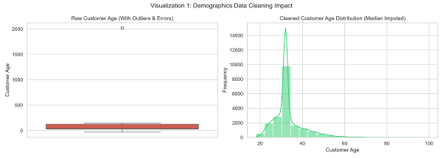Analysis: The raw boxplot (left) highlights severe anomalies in recorded ages, including negative values and unrealistically high numbers. The cleaned histogram (right) displays a normalized, unimodal age distribution centered around 35–45 years old following median imputation.
- Demographic Insight: The primary customer base consists of working professionals aged 30 to 50. Marketing campaigns should target this core group.
Visualization 2: Feature Correlation Matrix
- 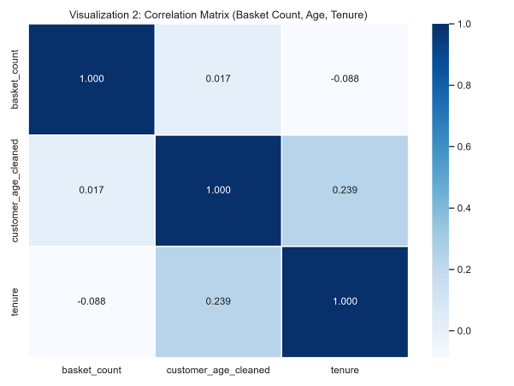
- Analysis: The correlation heatmap evaluates relationships between basket_count, customer_age_cleaned, and tenure.
- Statistical Finding: Correlation coefficients across features remain low (), indicating that basket order volume is largely independent of customer age or tenure length. Higher tenure alone does not guarantee larger basket sizes per visit.

Visualization 3: Daily Purchasing Trend
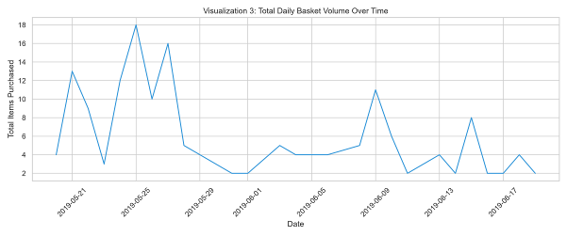
- Analysis: The time-series line chart plots total daily item volume over time.
- Operational Insight: Transaction volumes exhibit cyclical daily patterns with distinct periodic spikes. Operational logistics, server capacity, and customer support staffing should be scaled dynamically around these peak sales periods.
5. Summary of Insights & Business Recommendations
- Focus Marketing on Core Demographics: The 30–50 age bracket drives the highest transaction frequency. Tailored loyalty rewards and email campaigns directed at this demographic will yield higher engagement.
- Implement Cross-Selling Strategies: Because tenure does not automatically increase order size (basket_count), introduce targeted product recommendations and minimum-spend thresholds for free shipping to incentivize larger basket sizes.
- Automate Pipeline Validation: Implement automated data validation schemas at the entry point to catch invalid customer ages and malformed date strings before data enters the production database.

